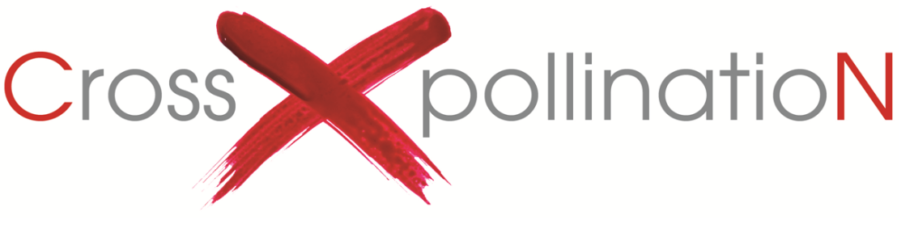

Welcome

Welcome to CrossXpollinatioN 2019, an exhibition which celebrates fibre and textile art and showcases the talents of artists from near and far. It is proudly supported by the Colac Otway Shire Council, as well as community sponsors Tarndie and the Baronga Motor Inn.

CrossXpollinatioN is now in its seventh year and aims to be an exhibition that supports growth in fibre and textile art by encouraging artists to inspire each other by ‘crossXpollinating’.

Theme

This year, CrossXpollinatioN celebrates excellence in the exploration of the theme ‘Connections’.

Judging criteria

Artwork must be three dimensional to be considered for the art prize.
Criteria 1: Artworks that show a large proportion of fibre or textile in their composition.
Criteria 2: Excellence and/or innovation in fibre and/or textile technique.
Criteria 3: The development of the ‘Connections’ theme as evidenced in the artist’s statement, and its articulation in the artwork.

CrossXpollinatioN is proudly brought to you by

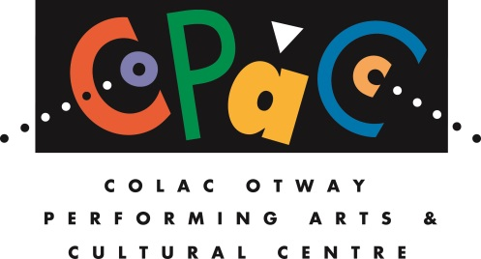

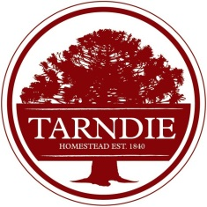
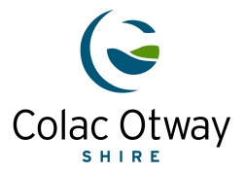
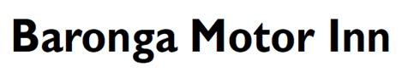

Awards on offer

Connections Art Prize - $2000
All entries are to be 3D in nature and will be displayed in the 'black box' theatre in COPACC’s Civic Hall. The exhibition is illuminated with dramatic theatre lighting effects to enhance the artworks. The space is ideal for larger 3D artworks (up to 4m x 4m). The Connections Art Prize is proudly sponsored by COPACC and the Colac Otway Shire Council.

The People’s Choice Award - $500
Throughout CrossXpollinatioN, visitors are encouraged to vote for their favourite piece of work. Feature or invited artists are not eligible for People’s Choice votes. Votes are tallied at the close of CrossXpollinatioN and announced via our social media pages. The People’s Choice Award is proudly sponsored by COPACC and the Colac Otway Shire Council.

Tarndie Fibre Art Award - $1500
To be eligible for this award, artists must submit a work that comprises at least 50 per cent wool that can be traced back to the farm where it was grown - this is referred to the fibre’s ‘provenance’. A statement must be provided with information about the breed of sheep and the source of fibre incorporated in the artwork. This award is designed to highlight the many and varied applications of wool from different breeds. It should promote a connection between the artist and the people, place and animals involved in growing the wool. Entrants should detail how this award would assist develop their art practice, e.g., spend prize money on taking classes, buy equipment, fund another project.

How to enter

Please ensure that you have read and accept the guidelines and terms and conditions for exhibiting in CrossXpollinatioN 2019 before signing the application and submitting your entry.

Completed entries should be emailed to: copacc@colacotway.vic.gov.au or
posted to: CrossXpollinatioN 2019 Entry, COPACC, PO Box 283, Colac VIC 3250

You are required to include the following with your application:

□ An Artist Profile or CV of no more than 1 x A4 page, in Word format (doc or docx)
□ An Artist Statement for each entry of no more than 50 words within this application form, outlining how the artwork relates to the theme
□ An Artist Provenance Statement for each entry to the Tarndie Fibre Art Award
□ Clearly labelled images of your work in jpeg format, no larger than 1mb each
□ Any specific requirements for exhibiting your work (display directions, hanging requests)
□ Public Liability Insurance – copy of current cover or completed form for Colac Otway Shire cover (included in this Entry Form)
□ Entry fee must be paid with application – cheque or credit/debit card details.
The entry fee is non-refundable.

Artist’s Name: ______________________________________ Phone:

Email Address:

Postal Address:

Signature:

Yes! Please add me to COPACC’s Newsletter mailing list □ and/or the CrossXpollinatioN mailing list □

Entry #1 □ This entry is also submitted for the Tarndie Fibre Art Award
Title:

Medium:

Size/dimensions (metric):
Weight (approx.):

Hanging or display advice (please note, hanging items must have hooks or attachments already in place upon delivery to COPACC):

Price: (Inclusive of 33% commission) $

Artist Statement (no more than 50 words):

Artist Profile/CV (no more than one page):

If entering the Tarndie Fibre Art Award

Provenance statement:

Artist statement on how prize money will be spent:

For multiple entries, please copy/cut/paste the Entry box above

Entry fee: $25 per artwork entry. Cheque enclosed □ Or please enter card details below

Card Number: Expiry: ______ /
Cardholder Name: CVV:
Please debit $ Signed:

Important dates

Entries Close: at 5pm, Thursday 30 May 2019
Artists notified of selection: by Friday 7 June
Delivery of artwork: 9am-4pm, Monday 17 June (or by arrangement).
Official Opening of Exhibition: 6.30pm, Thursday 27 June
Exhibition: 10am–4pm, Friday 28 June to Wednesday 17 July inclusive.
Collection of work: 9.30am-4.30pm, Thursday 18 July

Terms and conditions of entry
- Entries must be the artist/artists' original artwork.
- Artwork must have been created within the last two (2) years.
- All artwork should include an Artist Statement.
- Artists whose artwork is selected for exhibition must have public liability insurance. If you do not have this, please complete the Public Liability Insurance registration form attached to this Entry Form and return with your entry.
- Insurance of work is the responsibility of the Artist. Whilst all reasonable care will be taken with the handling of artwork neither COPACC staff nor volunteers will be responsible for any loss or damage to artwork for the duration of this exhibition.
- Transport to and from the exhibition is the sole responsibility of the artists and it is recommended that the artists obtain their own insurance.
- All entries must be ready for display with a securely attached label indicating the artist’s name and title of work.
- The Selection Panel’s decision is final and no correspondence will be entered into.
- The Award Judges’ decision is final and no correspondence will be entered into.
- The winners of the ‘Connections’ and Tarndie Awards will be announced and presented at the Official Opening of CrossXpollination 2019. The winner of the People’s Choice Award will be notified at the conclusion of the exhibition.
- All artworks must remain in the exhibition space until 4pm on the final day of the exhibition.
- Payment for artworks sold will be made to COPACC. A commission of 33% applies to all works and artists should factor this into the advertised sale price. The artist will be paid the balance after commission is deducted upon receipt of invoice to COPACC.
- COPACC reserves the right to use photographs of artwork for publicity, advertising and promotional purposes.

Queries
Please direct questions to the COPACC team on 5232 9418 or copacc@colacotway.vic.gov.au

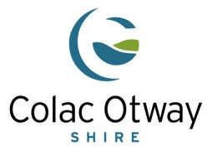
PUBLIC LIABILITY INSURANCE

FOR COLAC OTWAY SHIRE EVENTS ONLY

PERFORMER / STALLHOLDER / ARTIST

NAME:

ADDRESS:

CONTACT PHONE NO:

EVENT

DATE OF EVENT: 28 / 06 / 2019 To 28 / 07 / 2019

NAME OF EVENT: CrossXpollinatioN 2019

LOCATION: Colac Otway Performing Arts & Cultural Centre (COPACC) - Civic Hall, Civic Hall & Gallery Foyer

EVENT DESCRIPTION:

FreeZA Community Festival Event in a Public Place (Local Laws Permit Required)

Fundraising Event

Y OTHER

CrossXpollinatioN

APPLICANT IS: Musical Performer

Stallholder

Y Artist

Rock Band (Only covered when performing in a FreeZA event) Other_

NOTE: THIS POLICY DOES NOT PROVIDE COVERAGE FOR SPORTING ACTIVITIES, CHILD MINDING, SALE OF CHILDREN’S TOYS OR SECOND HAND ELECTRICAL ITEMS/TOOLS.

T-O--T-A--L--O--F--P--R-E--M--IU--M---$-4-5--.0--0

Waived

SUBJECT TO $250.00 EXCESS EACH AND EVERY LOSS

Upon the payment of the prescribed premium and completion of this form your liability as hirer is indemnified up to
$10,000,000

In the event of any claim, or the happening of any circumstances which may give rise to a claim, you must advise the Risk Services Officer of the Colac Otway Shire on 5232 9463 immediately.

ON BEHALF OF HIRER/HIRING GROUP DATE: _/ /

The personal information requested on this form/document is being collected for our Insurer Jardine Lloyd Thompson. The personal information will be used solely by Council for the primary purpose for which it was collected or a purpose the person would reasonable expect. The person providing the information understands that the personal information provided is for the purpose of obtaining Public Liability Insurance coverage and that he or she may apply to Council for access to and/or amendment of the information. Requests for access and or correction should be made to the responsible officer or the Privacy Officer.

Office Use Only Receipt #

